TRANSIENT RESPONSE ASSIGNMENT
Student Name
Institution
Course Name/Number
Due Date
Instructor Name

PART 1
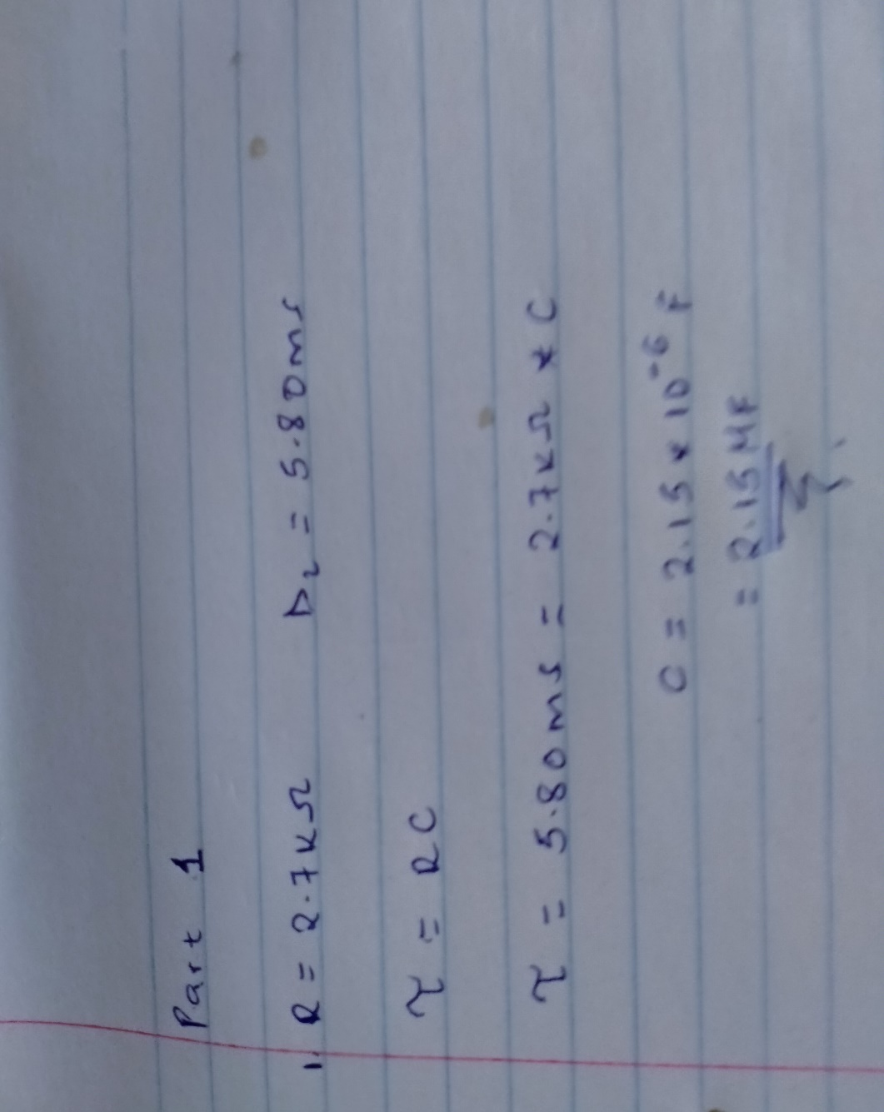
Figure showing the calculation that gives the C=2.15μF
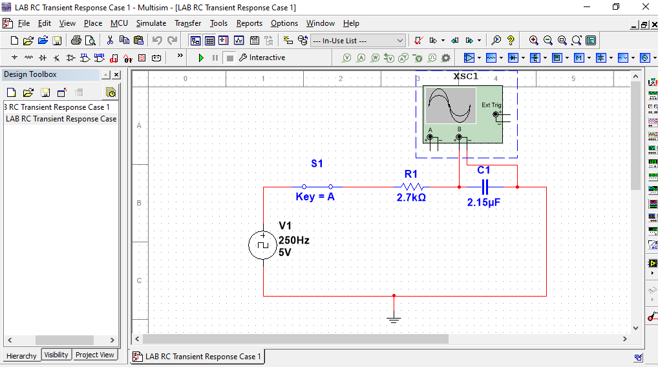
Figure showing the lab simulation for case 1 with R₁= 2.7kΩ and C₁ =2.15μF

PART 2
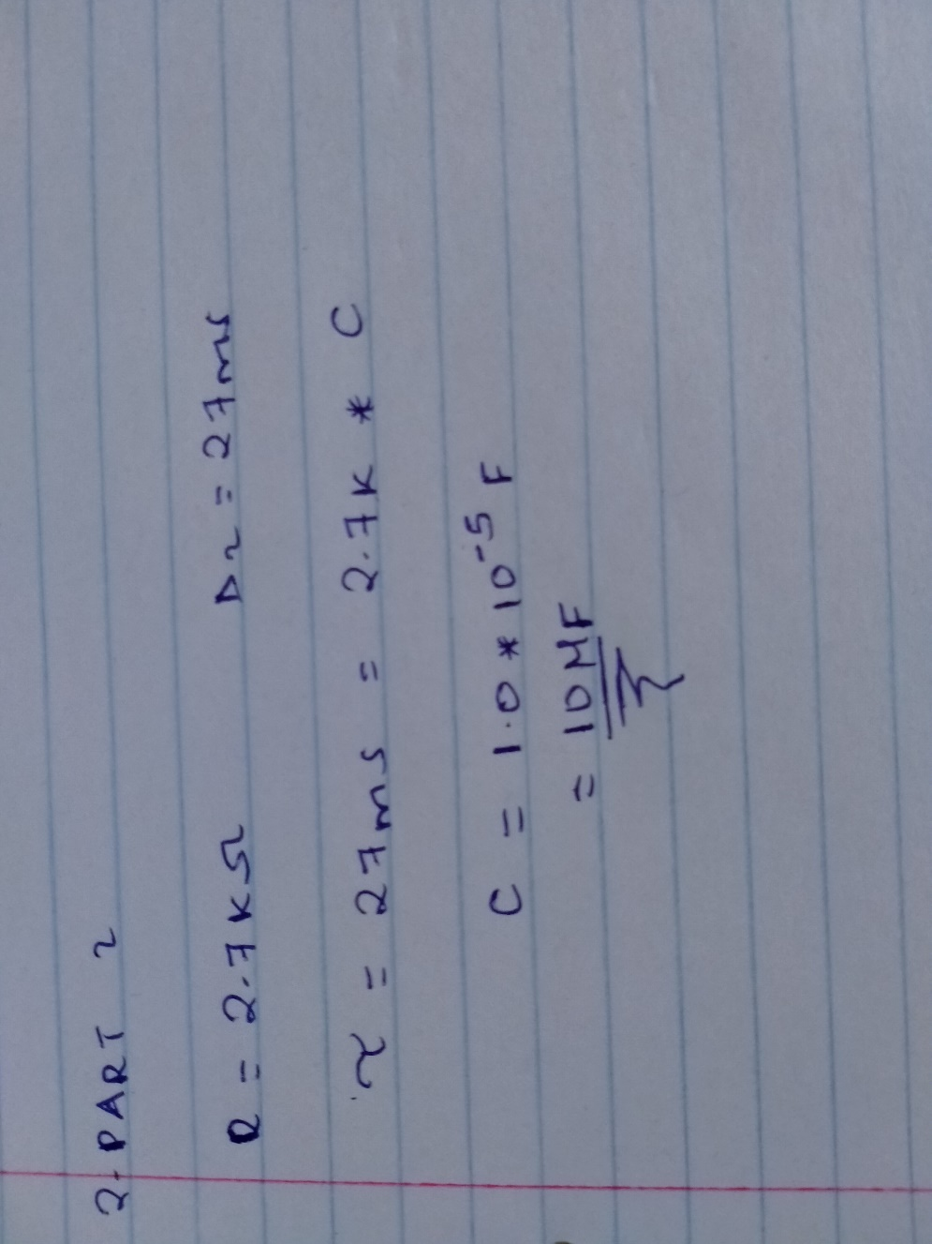
Figure showing the calculation that gives C =10μF
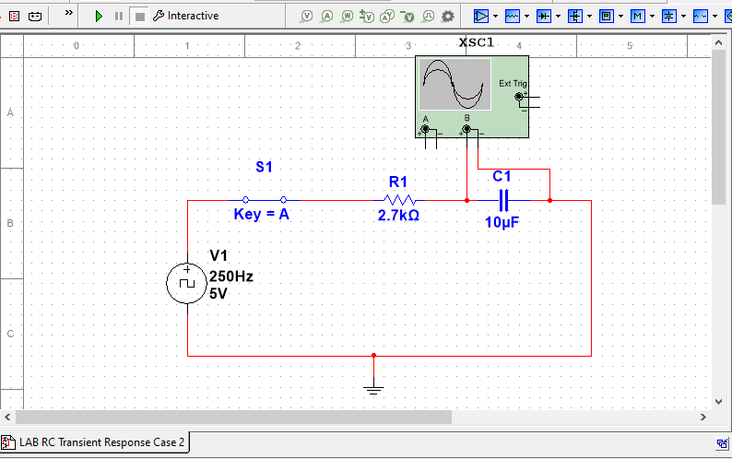
Figure showing the transient response for with R₁= 2.7kΩ and C₁ =10μF

REFERENCES
Allen, P. E., & Holberg, D. R. (2011). CMOS analog circuit design. Elsevier.
Robbins, A. H., & Miller, W. C. (2012). Circuit analysis: Theory and practice. Cengage Learning.

